# FRAUDS! are…

David Allen (dpallen@wpi.edu)

Henry Wheeler-Mackta (hjwheelermackta@wpi.edu)

## Working Game Title:

“Mino / Mono”

­­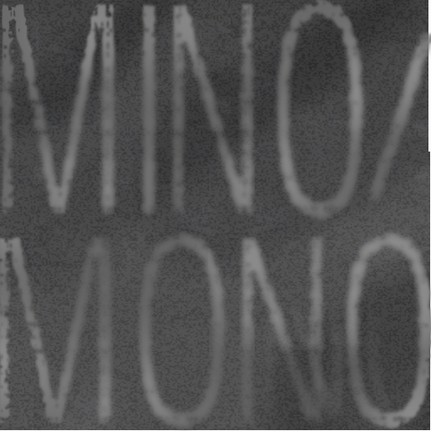

*Figure 1: Game Logo*

## Logline:

“Don’t let the fog obscure the way.”

## Summary:

Mino/Mono is an interactive puzzle game that relies on two things to ensure an engaging and entertaining experience: Memory, uniformity, and the inherent simplicity of both. The game features a monochromatic path of colors that stretch from bright to dark gray (bright at the origin, dark at the destination). Progressing from level to level is accomplished via dragging the cursor all the way from the bright end of the path to the dark end. However, the beads gradually fade from their initial color to the background color – ultimately rendering them indistinguishable. Speed, memorization, and precision is required.

* Navigate monochrome gradient paths from bright end to dark end
* The beads that make up the path fade into gray over time
* Levels are designed to gradually ease the player into the game’s various mechanics, rules, and limitations
* Following initial tutorial levels, levels are chosen from a random pool
* Features an ongoing background music track and fitting sound effects
* 100 levels!
* Endless mode!

The game will adhere to all five design restrictions, including…

* A 16x16 dimension grid
* No glyphs of any kind
* An entirely monochromatic color palate
* Entirely mouse-driven
* No usage of the status line

## Target Audience:

The target audience of Mino/Mono is casual gamers who want a fair yet engaging challenge. While technically classifying as a puzzle game, Mino/Mono cannot be beaten through careful consideration or trial-and-error. This is a game that demands attention and focus due to its memory and speed-based gameplay. Additionally, the game in its final form should be fully playable on mobile devices, thus widening the audience further.

## Experience Goals:

Mino/Mono will set out to evoke two primary emotions in the player – one directly and one indirectly. The first is despair, which is accomplished through the game’s mechanic of encroaching finality. Though the player must traverse various maze-like paths, the mazes themselves will ultimately take longer to complete than their proper order remains on the screen. Additionally, the game’s overall color palate furthers this tone of despair.

However, Mino/Mono is not intended to be melancholy. It is based entirely on the concept of short-term memory and quick thinking. Unless the player has superb memory, the most effective means of completing the game will be to trace the mazes before they disappear. Thus, as their skill with the game improves, the player’s mouse-movements will become precise, swift, and zen-like. In the context of this game, peacefulness will be reached through practice and mental fortitude.



## Gameplay Description:

### The Primary Grid

# A simple square of uniform tone, this grid will contain the path that the player must traverse. All beads will gradually fade to the same color as the primary grid. This play space’s size will depend on the given level, with earlier levels having a smaller grid due to having likewise shorter levels. The grid will ultimately cap out at being sixteen units wide by sixteen units long.

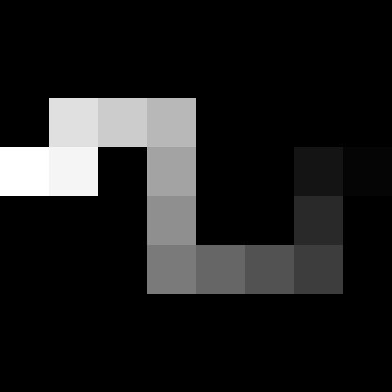

*Figure 2: A Linear Path*

### The Path

Each level will feature a linear path that exists on the grid. This path may be straight, jagged, curvy, or any potential shape – the only constant is that the path’s color will gradually progress from white to black. This path’s shape will be pseudo-randomized from level-to-level, with the possibilities being pre-designed yet chosen randomly once certain conditions are met.

*Figure 3 : A jagged path*

### The Certain Conditions to be Met

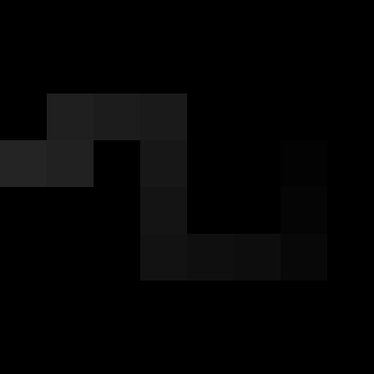

Due to the restrictions on the Perlenspiel status line and glyph usage, Mino/Mono’s level design will require carefully constructed tutorial levels that must be completed before the pseudo-random levels are introduced. These levels will introduce simple concepts such as traversing the path, the path’s fading properties, and the game’s various failure-states.

### Failure States

Mino/Mono has a single means of losing a given level: If the player drags their cursor over two beads in non-sequential order, the level will reset. This order is determined by the beads’ initial color pre-fade, and will not take background beads into consideration. Thus, when all of the beads have faded into the same color, they must still be traversed in order based on what color they were initially. If the player moves over beads in an incorrect order, a new level will be loaded. Trial-and-error will not be possible.

*Figure 4 : The same jagged path, now faded*

### The Levels

The level generation of Mino/Mono will be determined based on how many levels have already been completed. The initial levels will all be simple and intend to teach core game mechanics, with later levels being chosen randomly from a pool of pre-built levels.

### The Sound and Music

The sound effects of Mino/Mono were chosen to convey a sense of slightly awkward peace. All major in-game actions – including traversing the path, failing a level, loading a new level, etc. – have an accompanying sound effect that occurs nowhere else.

Additionally, the game has a permanently ongoing background track that plays following completion of the first level.

### Endless Mode

Figure 5: A level of endless mode

Upon completion of the initial 100 levels, an endless mode will be engaged. This mode will periodically spawn randomly-generated levels for the player to complete while the grid gradually fades to gray. Unlike the normal game, completing a level will not reset the grid’s fade. Rather, it will only postpone the fade by a few seconds.

When the grid completely fades to gray, the game is over. Upon completion, the grid will continue to flicker and jittery in color in a manner similar to radio static. This will continue until the game is manually restarted.

Additionally, endless mode will feature a separate background music track.

### Tutorials

Unlike the latter level pools, the first pool of levels in Mino/Mono are always played sequentially. Each level in this first pool serves the purpose of conveying a specific game mechanic or level design aspect to the player. Thus, by the time the player begins the more difficult levels in the more difficult pools, they will already be familiarized with every single potential mechanic.

## Playtest Survey

Did you understand that you had to click-and-drag? 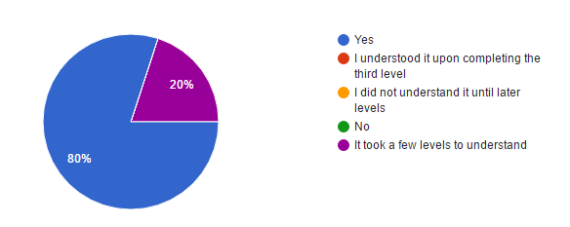

Did you understand that the colors fading signified a timer?

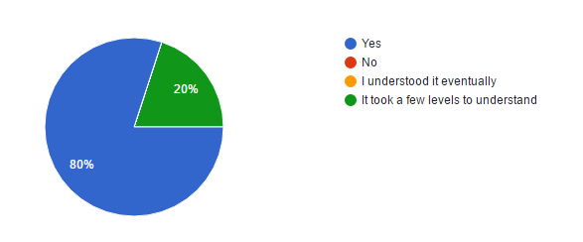

How did the background fading look to you?

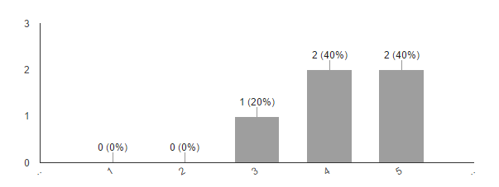

How did the color fading look to you?

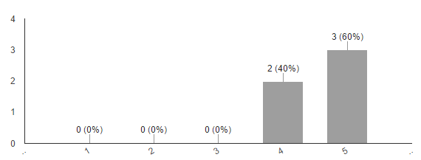

How enjoyable was the act of drawing lines?

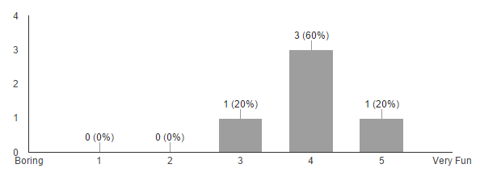

Did the fading colors convey a sense of urgency?

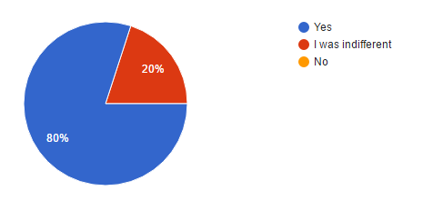

Did you understand when you failed a level?

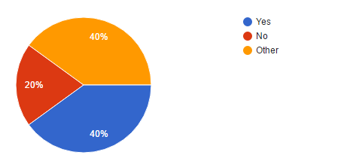

## Playtesting Notes:

* Players had difficulty immediately understanding how to control the game
  + The first level has been streamlined to necessitate the action of clicking-and-dragging
* There was a recurring bug where certain levels would not load another after failing
  + This, and many other bugs, were fixed
* Certain levels faded too quickly, others faded too slowly
  + All levels were rebalanced numerous times

## Critique Notes:

* It was still difficult to understand how to control the game
  + The tutorial was refined
* Earlier levels were too easy, later levels were also too easy
  + Difficulty was ramped up substantially, many levels were rebalanced
* The ending (or lack thereof) was poor
  + A potentially endless mode was added, along with a proper ending

## Product Details:

### Member Roles

David Allen - programmer, sound designer, mockups

Henry Wheeler-Mackta - programmer, writer, artist, producer